**TOP 10 BEST MIXED SENIOR HIGH SCHOOLS IN GHANA**

Senior high schools in Ghana are always in constant competition with one another when it comes to academics, sports, down to even the most beautiful school uniforms. Some believe that single sex schools are better than mixed schools since [**Ghana Education Service**](https://gh.opera.news/tags/ghana-education-service) categorizes most mixed school in category B, C and D.

Some mixed schools however stand out from the rest and this article will look at 10 of the best mixed schools in Ghana.

1. **Okuapeman Senior High School**

Established in 1957, it is a [**coeducational**](https://en.wikipedia.org/wiki/Coeducational) first-cycle institution in the heart of Akropong Eastern Region.

The school runs both day and boarding system with majority of the students in the boarding house. The school’s colours are brown and white, with brown signifying mother earth and nature and white depicting purity.

The school has trained a lot of diligent men and women in godliness, good character and responsibility. Many of its past students, called ‘Adehye’ are prominent personalities like **[Kwami Sefa Kayi](https://en.wikipedia.org/wiki/Kwami_Sefa_Kayi" \o "Kwami Sefa Kayi).**

The school practices an inclusive educational system which enables visually impaired students to have access to education, participate in activities and share facilities with the other students.

This school has certainly shown its superiority in providing good education in the country. General Art, Home Economics, General Science, Business, and Visual Art, are among the courses they offer.

CONTACT

Box Address: P. O. Box 99, Akropong Akwapim

Email:   [**okuas@okuas.20m.com**](mailto:okuas@okuas.20m.com)

**Call:   +233 24 478 6058,** [**+233 34 202 4345**](tel::+233342024345)

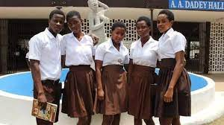

1. **Sunyani Senior High School**

Sunyani Secondary School popularly known as SUSEC was established in 1960 by Osagyefo Doctor Kwame Nkrumah, the then Prime Minister of Ghana. It is located in Sunyani the capital of the Brong Ahafo region.

SUSEC with the motto “Me man nti enye me nti” was awarded the Excellence in STEM Innovation Award during the 2022 WSSC.This school has also been a leader in terms of providing proper education in the region.

This school provides education in Agriculture, Business, Home Economics, General Science, Visual art and General art, etc.

Students who have passed out of Sunyani Secondary School have become Doctors, Nurses, Lawyers, Parliamentarians, Heads of institutions and Departments, Teachers, Private Businessmen and Women. Some notable alumni include;

* [**Ignatius Baffour-Awuah**](https://en.wikipedia.org/wiki/Ignatius_Baffour-Awuah) — Member of Parliament for Sunyani West Constituency and Minister for Employment
* [**Ernest Akobuor Debrah**](https://en.wikipedia.org/wiki/Ernest_Akobuor_Debrah) — Former Member of Parliament for Tano North Constituency

CONTACT

0352024914

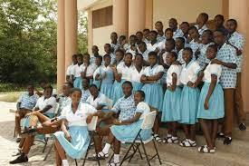

* 1. **Aggrey Memorial A.M.E Zion Senior High School**

The school was founded on 22 January 1940 in the heart of Cape Coast Township with the motto "Semper Optimo Nitere".  It takes students through a rigorous preparatory education with the aim of passing the [**WASSCE**](https://en.wikipedia.org/wiki/WASSCE). The school has distinguished itself as a leading secondary school by placing a high premium on educating students in the Arts and Sciences.

They also provide the highest quality education so that all of their students are empowered to lead productive and fulfilling lives as lifelong learners and responsible citizens of the community.

The school honours its cultural diversity by working as a team to ensure the educational success of all of their students and recognize that their obligations go beyond their professional responsibilities to promote democratic principles.

The school has also chalked a first in being the only second cycle school in the country to have fully computerized and networked its administrative system. The school also runs a computer literacy class for all students in the school to prepare them for the new world they would be entering after their schooling. The academic performance of students has always been high compared to that of sister schools.

CONTACT

Aggrey Senior High

P. O. Box 189, Cape Coast, Moree Hill, Ghana - West Africa.

Phone: [+233559672060](tel:+233559672060)

Email: [info@aggreymemorial.com](mailto:info@aggreymemorial)

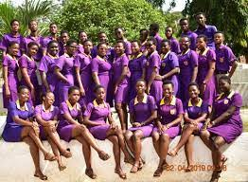

1. **Keta Senior High School**

Keta Senior High Technical School (Ketasco) formerly *Keta Secondary School*  was established on the 27th of February, 1953, and is a mixed [**Public**](https://en.wikipedia.org/wiki/Public_school_(government_funded))**Senior**[**High School**](https://en.wikipedia.org/wiki/High_school)**located at [Dzelukope](https://en.wikipedia.org/wiki/Dzelukope" \o "Dzelukope) a town in the**[**Keta Municipal District**](https://en.wikipedia.org/wiki/Keta_Municipal_District)**of the**[**Volta Region**](https://en.wikipedia.org/wiki/Volta_Region)**, Ghana.** Ketasco is the biggest school **in**[**Volta Region**](https://en.wikipedia.org/wiki/Volta_Region)**and one of the biggest in**[**Ghana**](https://en.wikipedia.org/wiki/Ghana)**.**

The motto of the school is ‘[**DZO LALI**](https://en.wikipedia.org/wiki/Ewe_people)’ with the slogan Now or Never.

Among its numerous achievements is that, in 2017, KETASCO took the App Silver award at the MTN APP Developer Challenger and in 2011 KETASCO won the National Constitution Game Competition.

KETASCO has always been among the first class second cycle schools in Ghana providing world class education to young men and women.

CONTACT

Dzelukofe Keta, Opposite The Residency of The Municipal Chief Executive (MCE)

Phone: 036 219 4864, 054 081 8158, 024 311 0762, 024 414 2892, 024 479 1422, 020 411 2374

Email: [ketashts@gmail.com](mailto:ketashts@gmail.com)

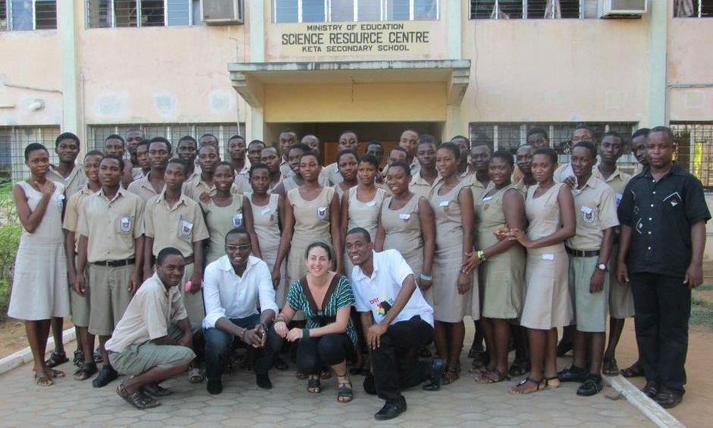

1. **Sekondi College**

**Sekondi College is a**[**co-educational**](https://en.wikipedia.org/wiki/Co-educational)[**second cycle**](https://en.wikipedia.org/wiki/Second_cycle)**school in [Sekondi](https://en.wikipedia.org/wiki/Sekondi" \o "Sekondi) in the**[**Western Region**](https://en.wikipedia.org/wiki/Western_Region_(Ghana))**of**[**Ghana**](https://en.wikipedia.org/wiki/Ghana) established in 1951

The vision of the school is to provide a holistic education that guarantees a firm foundation for higher academic pursuit and self-discovery while inculcating a sense of discipline and selflessness in the students. Their mission is to create a conducive environment that allows effective teaching and learning, total personality development, positive moral upbringing, and enforcement of discipline.

The school also believes that practical work is an essential part of any training programme that seeks to equip students with skills that will make them effective and more productive.  In line with this belief, practical agriculture is seriously pursued in the school.

Sekondi College offers six major academic programs namely; General Arts, Home Economics, General Science, Business, Visual Arts, Agricultural Science

Among their achievements are:

* Best second cycle Farming school (STMA) – 2017
* Best SHS (Western region) – 2015

CONTACT

Telephone: 020 790 7373  
Email: sekondicollege@ges.gov.gh  
Location: Sekondi  
Latitude: 4.980607  
Longitude: -1.686294  
District: Sekondi / Takoradi Metropolitan

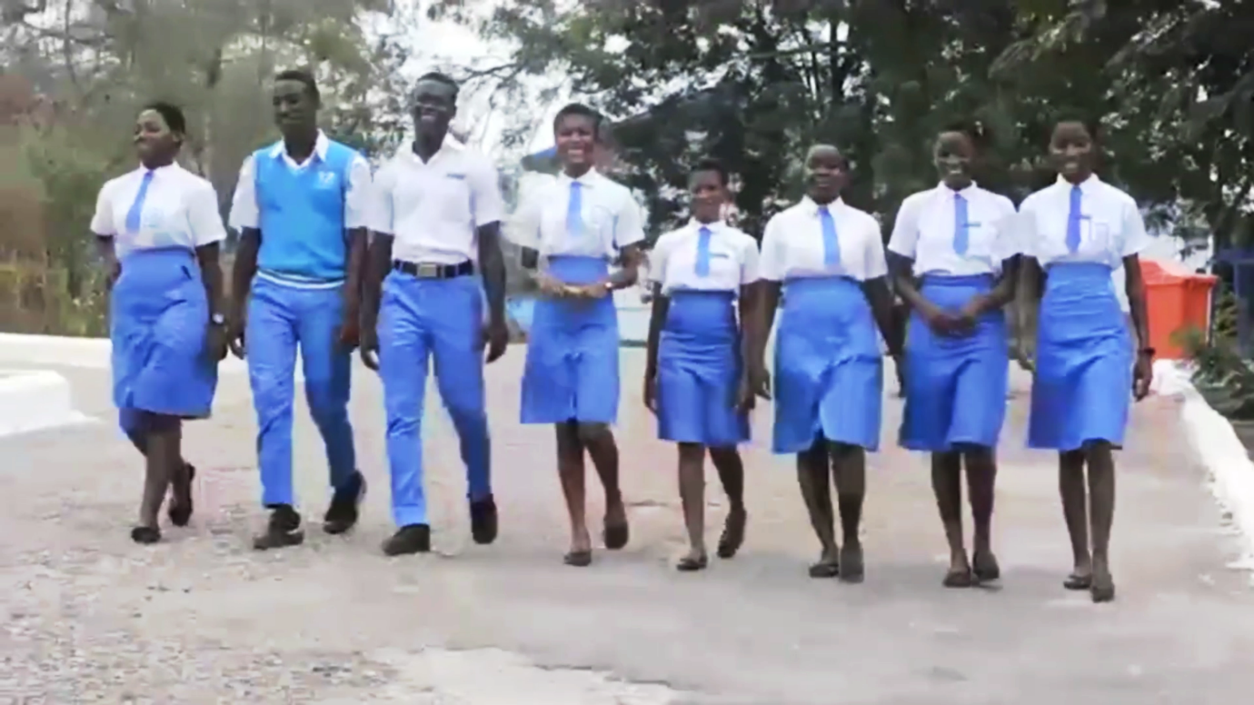

1. **Ghana National College**

Ghana National College was established on Friday, July 16th, 1948  in Cape Coast

Ghana National College is a co-ed boarding secondary school (high school) with roots originally stemmed in the sciences but currently offering a wide range of core and elective high school courses from fine arts to languages and business.

A collaborative educational community focused on fostering academic achievement in a nurturing environment that instills the essential value of an excellent education, and prepares students to live and work in a global community.

Notable alumni include:

* [**Nana Aba Anamoah**](https://en.wikipedia.org/wiki/Nana_Aba_Anamoah)**, media personality, news anchor and broadcaster**
* [**Kwesi Armah**](https://en.wikipedia.org/wiki/Kwesi_Armah)**, formerly Ghana's High Commissioner to the United Kingdom**
* **General**[**Emmanuel Alexander Erskine**](https://en.wikipedia.org/wiki/Emmanuel_Alexander_Erskine)**, 1st UNIFIL Commander**
* [**Gladys Asmah**](https://en.wikipedia.org/wiki/Gladys_Asmah)**– Former** minister of Fisheries

CONTACT

P. O. Box 161  
Cape Coast, Ghana

Telephone: 0(233) 04232357  
Email: [ghanacol@yahoo.com](mailto:ghanacol@yahoo.com)

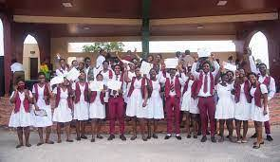

1. **Mawuli Senior High/Technical school**

**Mawuli School is a**[**co-educational**](https://en.wikipedia.org/wiki/Co-educational)**,**[**boarding**](https://en.wikipedia.org/wiki/Boarding_school)**senior high school located in**[**Ho**](https://en.wikipedia.org/wiki/Ho,_Ghana)**in the**[**Volta Region**](https://en.wikipedia.org/wiki/Volta_Region)**of**[**Ghana**](https://en.wikipedia.org/wiki/Ghana)**.** The school was founded in 1950 and was the first senior high school to be established in the [**Trans-Volta Togoland**](https://en.wikipedia.org/wiki/Trans-Volta_Togoland)

Known as the pride of Volta Region, Mawuli has been referred as the University of the Volta Region. The school has not only produced intellectuals and great personalities the country has got but has also impacted a lot into them with their exclusive motto HEAD HEART and HAND. The school is on a mission “To offer holistic education to the individual’s whole being, – Head, Heart, and Hand.

It offers almost all the courses the country offers (GENERAL ARTS, VISUAL ARTS, BUSINESS, TECHNICAL, HOME ECONOMICS, GENERAL SCIENCE).

It is the biggest school in the Volta Region. It also accommodates and accepts visually-impaired students who have their own well-furnished centre in the school.

The vision of the school is to establish a Christian institution that would give training at second cycle level to both boys and girls in the various disciplines with prominence given to Agriculture.

CONTACT

Tel: 091-26533 and 091-26221

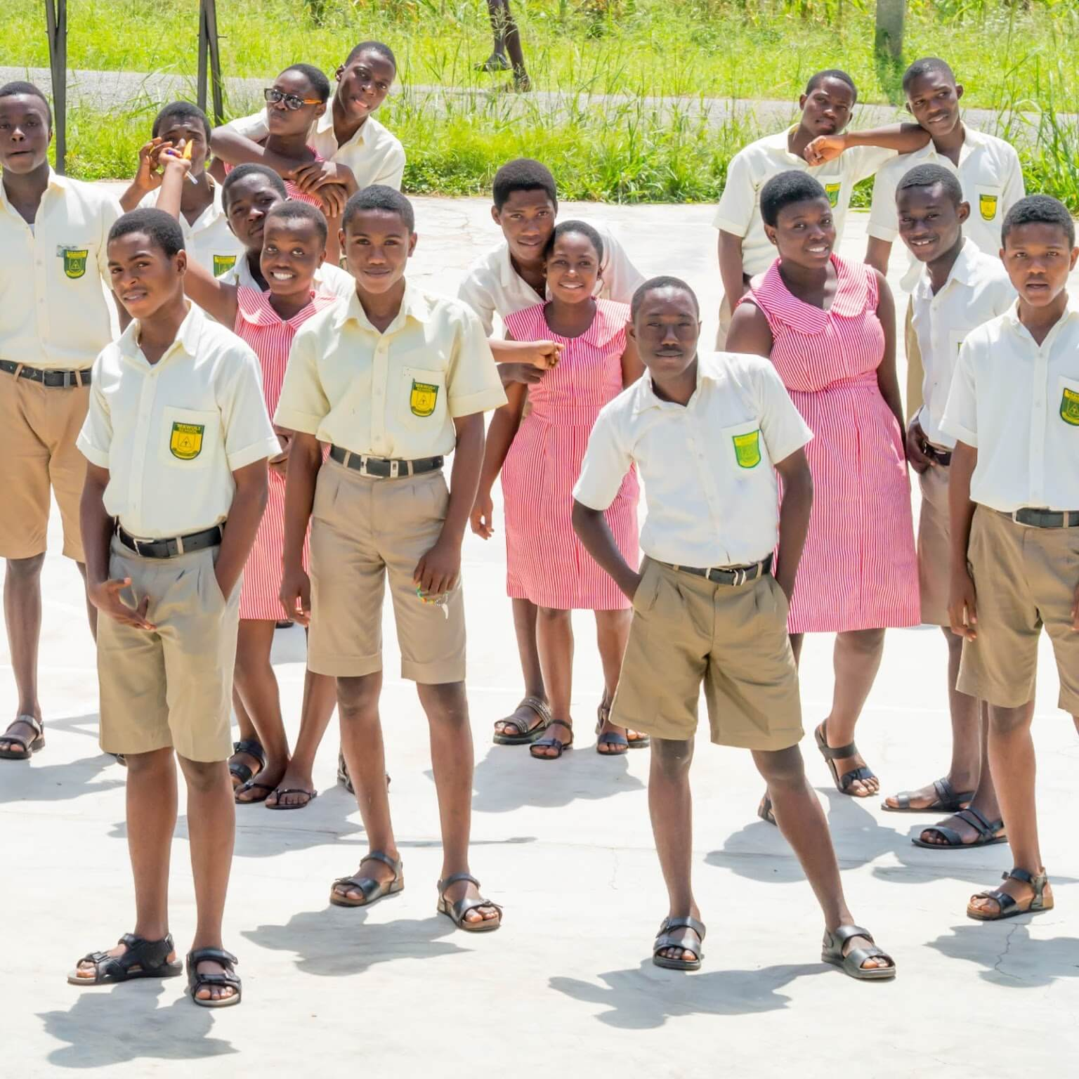

1. **Koforidua Senior High School**

Koforidua Senior High Technical School was established in the year 1967 and has become one of the best secondary technical schools in Ghana. The school is located at Koforidua, the capital of Eastern Region in southern Ghana.

 The school’s slogan “Mmarima Mma” means when transliterated, Sons of Men. Academically, the school is well-noted. The school is classed among the Class A schools in Ghana. Over the years its students have performed exceptionally well in WASSCE

The school existed as a Boys School since its establishment, until recently few girls were introduced of about 5% of the overall student population.

Notable alumni of the school are;

* [**Benedict Ernest Donkor**](https://en.wikipedia.org/w/index.php?title=Benedict_Ernest_Donkor&action=edit&redlink=1)**, a Ghanaian pilot**
* [**DJ Aroma**](https://en.wikipedia.org/wiki/DJ_Aroma)**, a Ghanaian DJ**
* [**Vision DJ**](https://en.wikipedia.org/wiki/Vision_DJ)**, a Ghanaian DJ**
* [**Prince Tagoe**](https://en.wikipedia.org/wiki/Prince_Tagoe)**, a Ghanaian Footballer**

**CONTACT**

Call:[+233 20 813 7250](tel::+233208137250)

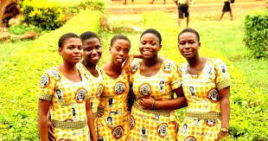

1. **Ghana Senior High School**

**Ghana Senior High School, Koforidua, popularly known as GHANASS, is a**[**high school**](https://en.wikipedia.org/wiki/High_school)**in**[**Koforidua**](https://en.wikipedia.org/wiki/Koforidua)**, Eastern Region.** In 1943 the school was established and was later renamed by Osagyefo **Dr.**[**Kwame Nkrumah**](https://en.wikipedia.org/wiki/Kwame_Nkrumah)  from Christ College to Ghana Secondary School.

The motto of the school “*Pro Patria”*, seeks to instil in all who pass through GHANASS a sense of patriotism to offer dedicated service to the school and to the nation.

Ghana Senior High School Koforidua Is a Category A School and offers six courses; General Arts, General Science, Business, Agriculture, Home Economics, Visual Arts.

The vision of the school is to be the best co-educational institution that holistically trains students to be responsible citizens. Their mission is also to pursue quality teaching, learning and supervision through strategic planning and implementation of policies by all stakeholders.

Some of the school’s achievements include;

* 2nd in the 1st National Best School Awards
* Winner of the special showcase on early child and forced marriage in the Eastern Region

CONTACT

Telephone: 020 882 0410

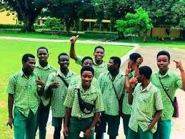

1. [**Achimota**](https://gh.opera.news/tags/achimota) **Senior High school**

Since its founding in 1927, **at**[**Achimota**](https://en.wikipedia.org/wiki/Achimota)**in**[**Accra**](https://en.wikipedia.org/wiki/Accra)**, Achimota** School has been dedicated to expanding, training transformational leaders, inspiring creativity, innovation and critical thinking among students, and preserving the cultural identity of Ghana through various programs.

Their quest to develop students holistically is grounded in a mission and vision that integrates the core competences to the benefit of learners.

Achimota School, nicknamed Motown, has for long been regarded as the best co-educational school in Ghana, offers a broad and balanced GES-based curriculum that meets the needs of all students, with facilities that enable the teaching and learning of General Science, General Arts, Agricultural Science, Visual Arts, and Home Economics.

Educating the total being of boys with girls not just in the academics but to make the best use of the minds and bodies, and have respect for all that is true and of lasting value in the Old African Culture, beliefs and ways of life.

The school has educated many Ghanaian leaders, including [**Kwame Nkrumah**](https://en.wikipedia.org/wiki/Kwame_Nkrumah)**,**[**Edward Akufo-Addo**](https://en.wikipedia.org/wiki/Edward_Akufo-Addo)**,**[**Jerry John Rawlings**](https://en.wikipedia.org/wiki/Jerry_Rawlings)**, and**[**John Evans Atta Mills**](https://en.wikipedia.org/wiki/John_Evans_Atta_Mills)**all of whom are former**[**Heads of State of Ghana**](https://en.wikipedia.org/wiki/Heads_of_State_of_Ghana)**.**

Some of the school’s achievements include;

* Won The National Science & Math Quiz Competition Twice (1998 And 2004)
* 2018 WASSCE – Placed 3rd In Greater Accra
* Inter Schools Games – Overall – 1st

CONTACT

[**+233 302 40 0552**](https://www.achimota.edu.gh/)

[**info@achimota.edu.gh**](mailto:info@achimota.edu.gh)

[**GA-297-5281. GPS**](https://www.achimota.edu.gh/)

